**Bahria University, Lahore Campus**

Department of Computer Sciences

Lab Journal 08

**(Fall 2023)**

|  |  |  |
| --- | --- | --- |
| Course: | **Database Management System Lab** |  |
| Course Code: | CSL 220 | Max Marks: |
| Faculty’s Name: |  | Lab Engineer: |

Name: affan ahmad Enroll No: _03-134221-003__

**Subquery**

**Task 1**

Use the following Table Perform the following tasks

|  |  |  |  |  |  |  |  |  |  |  |
| --- | --- | --- | --- | --- | --- | --- | --- | --- | --- | --- |
| EMPLOYEE_ID | FIRST_NAME | LAST_NAME | EMAIL | PHONE_NUMBER | HIRE_DATE | JOB_ID | SALARY | COMMISSION_PCT | MANAGER_ID | DEPARTMENT_ID |
|  |  |  |  |  |  |  |  |  |  |  |

1. Write a SQL query to find those employees who receive a higher salary than the employee with ID 163. Return first name, last name.

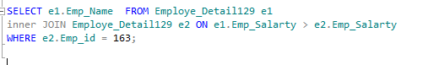

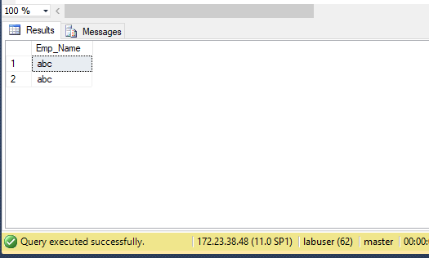

1. Write a SQL query to find out which employees have the same designation as the employee whose ID is 169. Return first name, last name, department ID and job ID.

SELECT e.Emp_Salarty , d.Dept_id, e.job_id

FROM Employe_Detail127 e,Department_Detail129 d

WHERE job_id =

( SELECT job_id

FROM Employe_Detail127

WHERE Emp_id=169

);

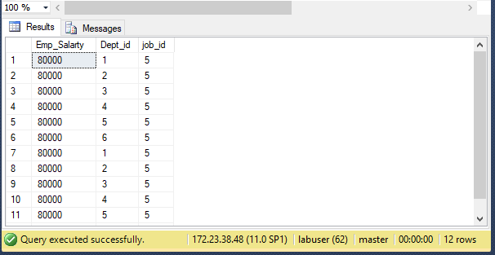

1. Write a SQL query to find those employees whose salary matches the lowest salary of any of the departments. Return first name, last name and department ID.

SELECT Emp_Name, Emp_Salarty, Dept_id

FROM Employe_Detail127

WHERE Emp_Salarty IN

( SELECT MIN(Emp_Salarty)

FROM Employe_Detail127 e , Department_Detail128 d

where e.Dept_id=d.Dept_id

);

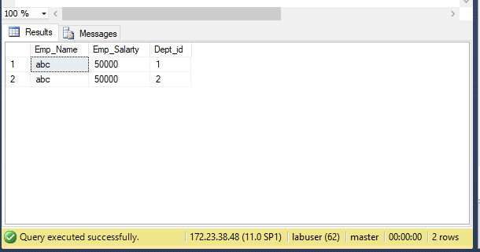

1. Write a SQL query to find those employees who earn more than the average salary. Return employee ID, first name, last name.

SELECT Emp_Name, Emp_Salarty, Dept_id

FROM Employe_Detail127

WHERE Emp_Salarty >

( SELECT avg(Emp_Salarty)

FROM Employe_Detail127 e , Department_Detail128 d

where e.Dept_id=d.Dept_id

);

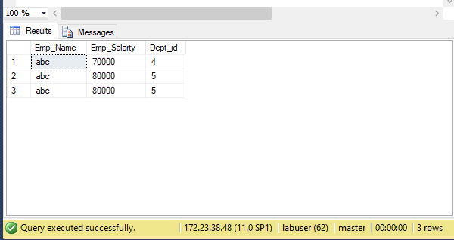

1. Write a SQL query to find those employees who report to that manager whose first name is ‘Payam’. Return first name, last name, employee ID and salary.

SELECT Emp_Name, Emp_id , Emp_Salarty

FROM Employe_Detail127

WHERE manager_id =

(SELECT Emp_id

FROM Employe_Detail127

WHERE Emp_Name = 'Payam'

);

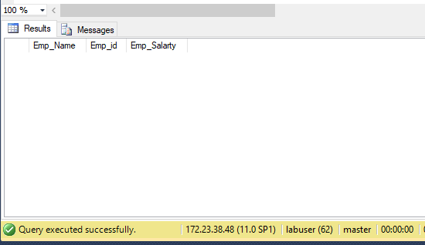

1. Write a SQL query to find the employee whose salary is 3000 and reporting person’s ID is 121. Return all fields.

SELECT *

FROM Employe_Detail127 e

WHERE e.Emp_Salarty = 3000

AND EXISTS (SELECT 1 FROM Employe_Detail127 m WHERE m.Emp_id = 121 AND e.manager_id = m.Emp_id);

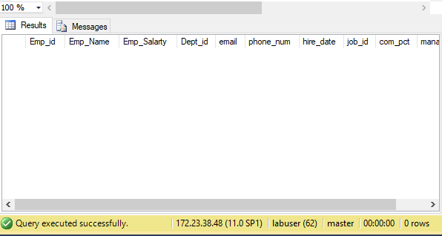

1. Write a SQL query to find all those employees who work in the Finance department. Return department ID, name (first), job ID and department name.

SELECT *

from Department_Detail128

WHERE Dept_id =

(SELECT e.Dept_id

FROM Employe_Detail127 e

);

**Joins**

**Task 2**

Implement this database

create database JOINS

use joins

create table Employe_Detail

(Emp_id int primary key ,

Emp_Name nvarchar(15),

Emp_Salarty int ,

Dept_id int foreign key references Department_Detail (Dept_id )

);

Create table Department_Detail

(

Dept_id int not null primary key ,

Dept_Name nvarchar (15)

);

create table Employe_Detail127

(Emp_id int primary key ,

Emp_Name nvarchar(15),

Emp_Salarty int ,

Dept_id int foreign key references Department_Detail (Dept_id ),

email varchar (50),

phone_num int ,

hire_date varchar(25),

job_id int ,

com_pct int ,

manager_id int ,

);

Create table Department_Detail128

(

Dept_id int not null primary key ,

Dept_Name nvarchar (15),

job_id int

);

**Task 3**

Insert data

insert into Employe_Detail values (1, 'abc',50000,1);

insert into Employe_Detail values (2, 'abc',50000,2);

insert into Department_Detail values (1,'CS'),(2,'BS'),(3,'EE'),(4,'IT'),(5,'BBA'),(6,'MBA')

select * from Employe_Detail

select * from Department_Detail

insert into Employe_Detail127 values (1, 'abc',50000,1,'adaw',003,23,1,1000,1);

insert into Employe_Detail127 values (2, 'abc',50000,2,'adad',567,23,2,5000,2);

insert into Employe_Detail127 values (163, 'abc',60000,3,'adasd',678,23,3,67000,3);

insert into Employe_Detail127 values (160, 'abc',70000,4,'adad',234,23,4,89000,4);

insert into Employe_Detail127 values (169, 'abc',80000,5,'adada',434,23,5,30000,5);

insert into Employe_Detail127 values (161, 'payam',80000,5,'adada',434,23,5,30000,5);

insert into Department_Detail128 values (1,'CS',1),(2,'BS',2),(3,'EE',3),(4,'IT',4),(5,'BBA',5),(6,'MBA',6)

**Task 4**

Implement joins

select * from Employe_Detail

inner join Department_Detail

on

Employe_Detail.Emp_id = Department_Detail.dept_id;

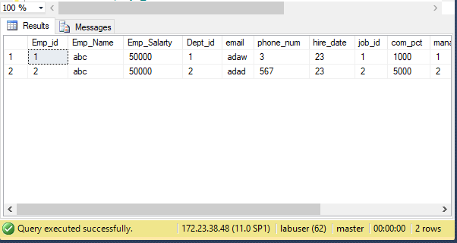

select * from Employe_Detail

left join Department_Detail

on

Employe_Detail.Emp_id = Department_Detail.dept_id;

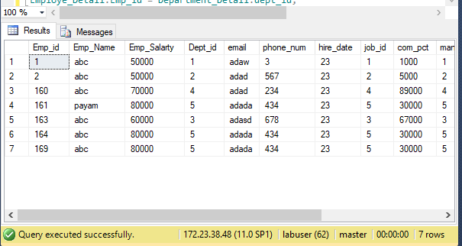

select * from Employe_Detail

right join Department_Detail

on

Employe_Detail.Emp_id = Department_Detail.dept_id;

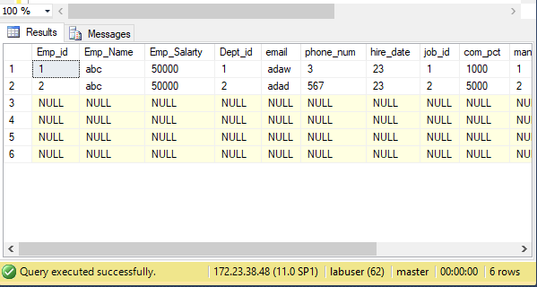

select * from Employe_Detail

full join Department_Detail

on

Employe_Detail.Emp_id = Department_Detail.dept_id;

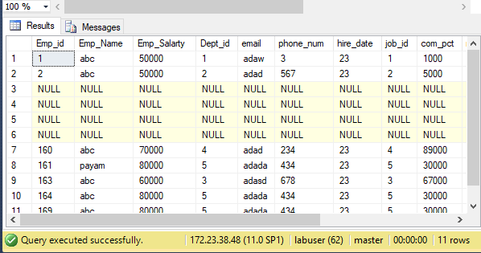

**Lab Grading Sheet :**

|  |  |  |  |
| --- | --- | --- | --- |
| **Task** | **Max Marks** | **Obtained Marks** | **Comments(*if any*)** |
| 1. | 10 |  |  |
| 2 | 10 |  |  |
| 3 | 10 |  |  |
| 4 | 10 |  |  |
| **Total** | **40** |  | **Signature** |

**Note : Attempt all tasks and get them checked by your Lab. Instructor**